How to create a report of the number of reading lists created per year | 

Yoel Kortick
Senior Librarian

ONE
Create a report in the “Course Reserves” subject area

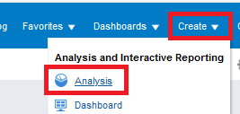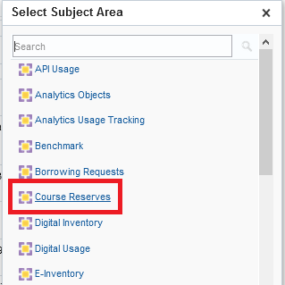

TWO
Display the following fields:

- "Reading List > Reading List Create Date (Calendar)"
- "Reading List > Reading List ID"

THREE

In the criteria tab filter by Course Create Date (Calendar) is not null (just filter by this field but do not display it)

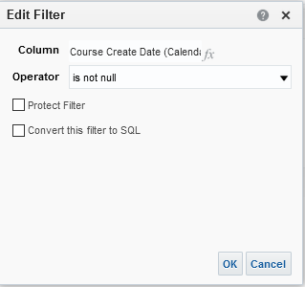

FOUR
Do “Edit Formula” on “Reading List Create Date (Calendar)”.
We will change the full date to just the year.

change
"Reading List"."Reading List Create Date (Calendar)"
To
YEAR("Reading List"."Reading List Create Date (Calendar)")

Make the Name be “Reading List Create Date Year”

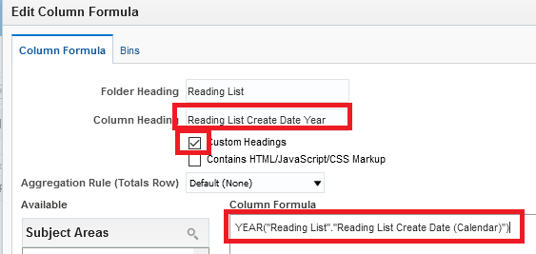

FIVE

Do “Edit Formula” on “Reading List ID”

Change
"Reading List"."Reading List Id"
To
COUNT(DISTINCT "Reading List"."Reading List Id")

Make name be “Number of Reading Lists”

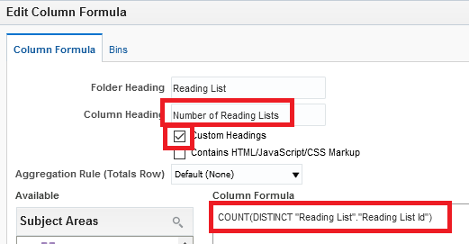

SIX

Switch to “Results” tab and drag “Reading List Create Date Year” to the left (if it is not there already):

